ARM: Access Request Management
VIRSA 4.0 ------ > Access Enforcer (AE)
GRC AC 5.1, 5.2, 5.3 ------- > Compliant User Provisioning (CUP)
GRC AC 10, 10.1,12-------> Access Request Management (ARM)

ARM will take care of the below:
- Automate Approvals and Documentation through MSMP Workflow
- Auto Provisioning – Automatic user maintenance
Advantages of Automation: (RPA - Robotic Process Automation)
- No time delays
- Reduction of human errors
- Enforce the Process to be followed - Workflow

User Administration – User creation, user modification and User deletion
Process to be followed for user administration
- User has to fill the SAP Access form
- It has to be approved by his Reporting manager
- It has to be approved by Role Owner ( for the roles user is requesting)
- Security team will create or modify or delete user as per the request
How can you ensure that above process is not violated?

Automation & Workflow designing can be done for the following
- Process of user administration – Non HR & HR System(2) - ARM
- Role Approval(1) - BRM
- Function maintenance Approval(1) - ARA
- Risk Maintenance Approval(1) - ARA
- FF log report review(1) - EAM
- Review – SOD Review & User Access Review(2) - ARA
- Mitigation Control – Maintenance and Assignments Approvals -(2) ARA
Process IDs (Work flow types)
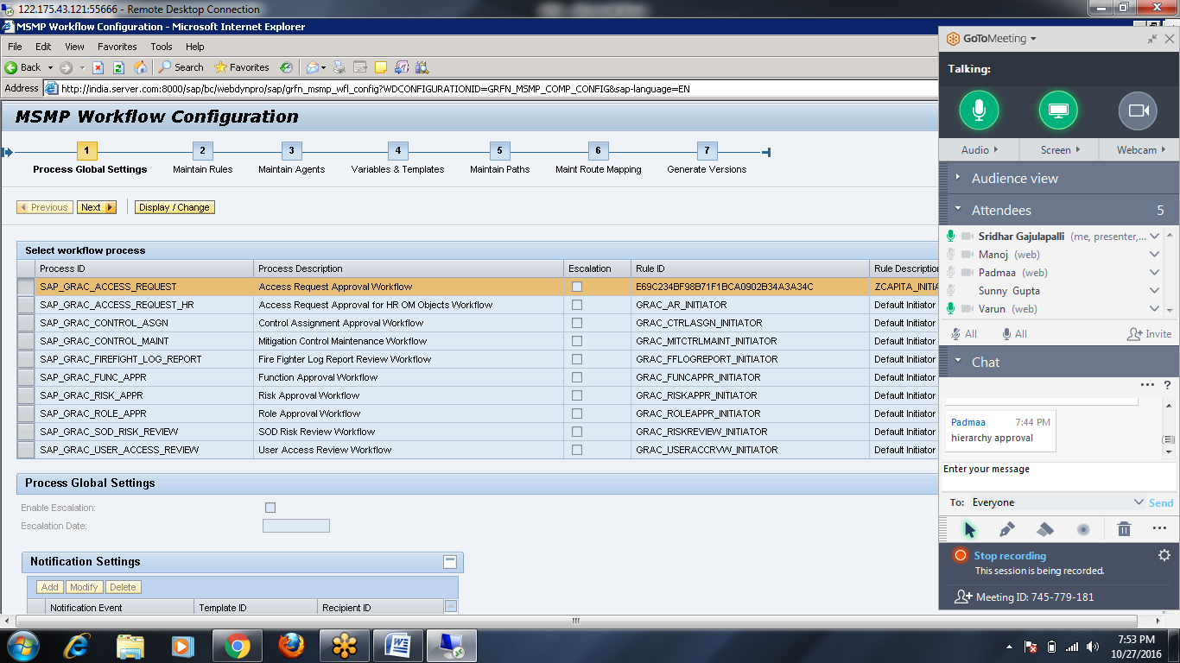

ARM configuration is done in the below path
- Auto Provisioning: GRC ----- > AC ----- > User Provisioning
- Workflow: GRC ----- > AC ----- > Workflow for Access Control

Maintain Settings for HR Trigger
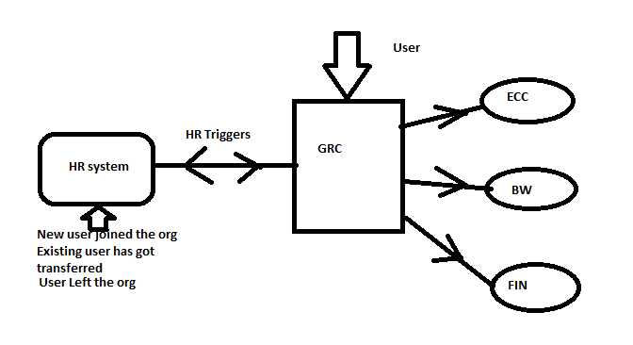

HR Master is created --- Action ID 00001 -----> New Account
HR Master is modified --- Action ID 00002 -----> Change Account
HR Master is deleted --- Action ID 00003 ------> Delete Account

Maintain Service Level Agreements (SLA):
- SLA can defined based on Process ID (workflow Type)
- It can’t be defined based on Request type
Define Request Type:
Correctly map request types to the respective Process IDs or workflow types
Ex,,
Access request approval workflow will have following request types
- New user creation
- Change user
- Delete User
- Lock User

Risk approval workflow will have following request types
- Risk creation
- Risk Modification
- Risk Deletion
Function approval workflow will have following request types
- Function creation
- Function Modification
- Function Deletion
Maintain Number Range Intervals for Provisioning Requests:
This is related to the Access request number (range) that is generated during submission of Access request by user.
Object: GRACREQNO
Number Ranges ----- > Modify Intervals ----- > Insert Interval

Define Number Range for Provisioning Requests:
Choose the appropriate number range as active

Maintain End User Personalization: (EUP)
Access Form customization
Access form Fields can be made as
- Mandatory (YES/NO)
- Editable (YES/NO)
- Visible (YES/NO)

Maintain Provisioning Settings:
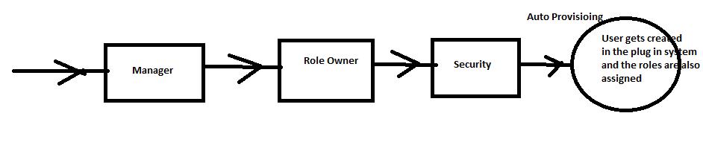
Role Provisioning Type
- Direct(SU01 role assignments)
- Indirect (HR system – Position or Org Unit based role assignments)
- Combined
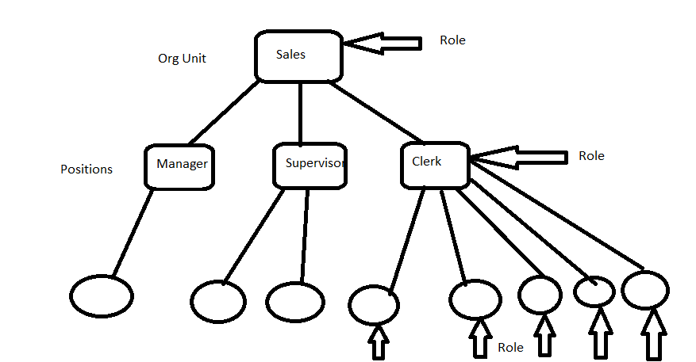
Auto Provisioning
Select: Auto Provisioning at end of the request
What is difference between?
- Auto Provisioning at the end of the request
- Auto Provisioning at the end of the path
What is difference between?
- Auto Provisioning
- Manual Provisioning
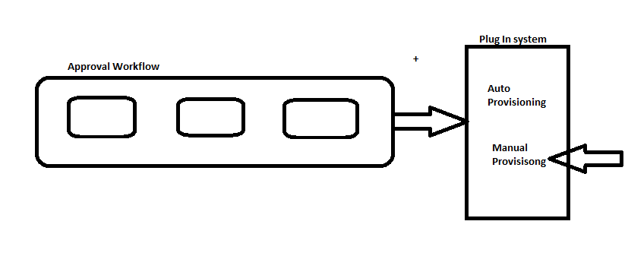
Maintain User Defaults:
This is related to DEFAULTS tab under SU01
CUA Settings
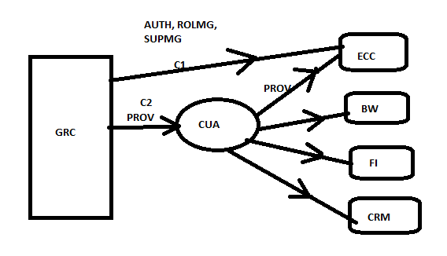

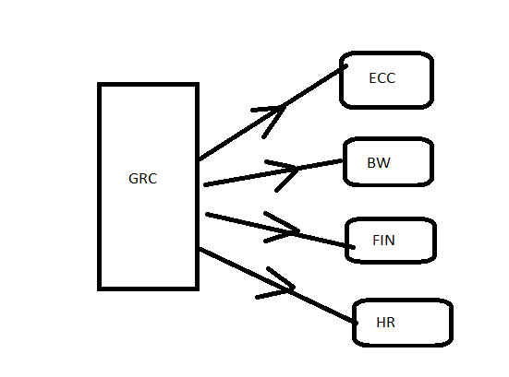

- SLA can be defined at Process ID level only.
- Number Ranges Object is GRACREQNO

EX,, Access Request Workflow ------- > Process ID
- New user Request
- Change user request
- Delete User Request

GRC Fiori Roles:

Workflow Configuration:
Access Control ----- > Workflow for AC ------- > Maintain MSMP Workflows
MSMP – Multi Stage Multi Path
Process IDs (Workflow types) – 10 Types of workflows

Work flow configuration is 7 step processes
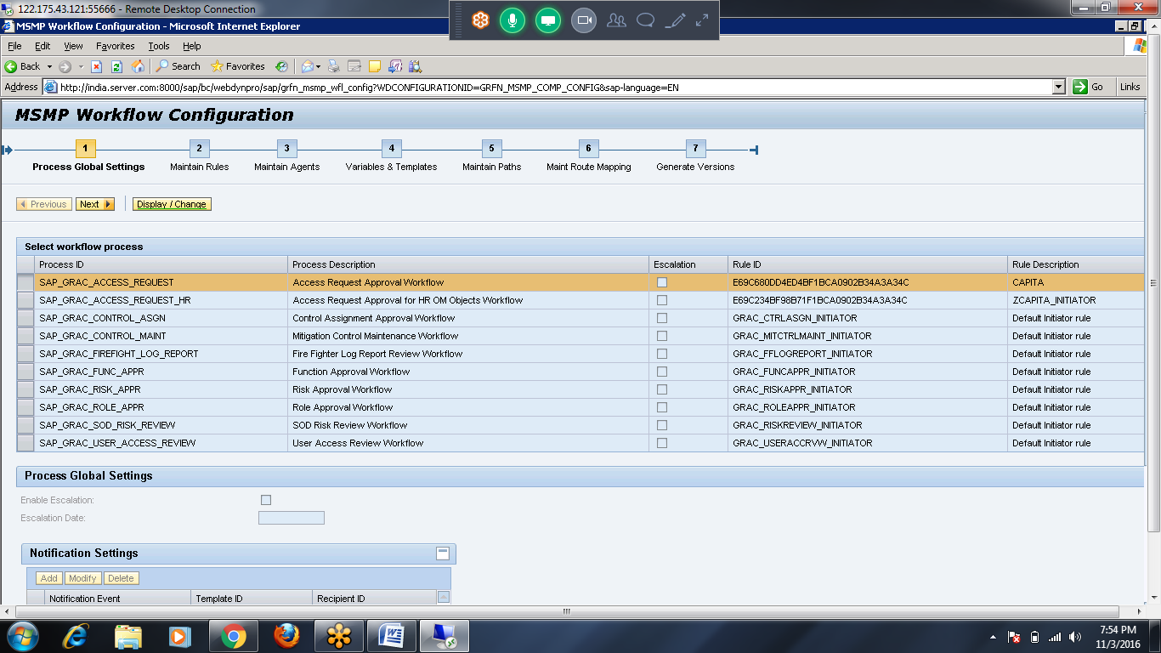

- Process Global Settings:

- Decide which workflow type/process id you are working on and that has to be selected
- Decide which mode to be used – DISPLAY/CHANGE
- Notification Settings - Request Submission and End Of the request
- Escape Conditions

Escape Conditions:
- Approver Not Found
- Auto Provisioning Failure

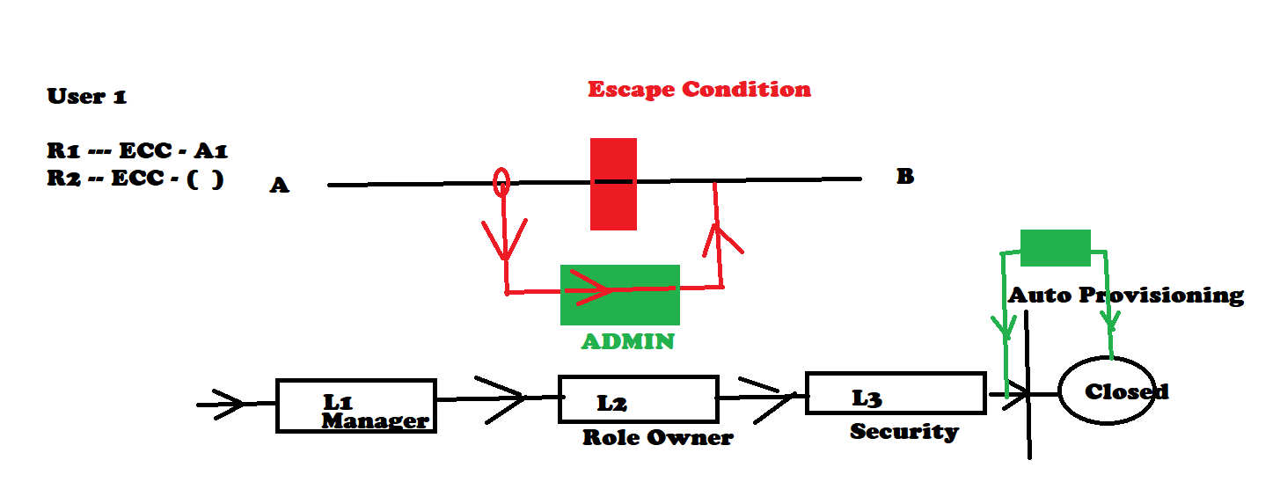

- Maintain Rules

Rule Kinds: (Kinds of Rules)
- Initiator Rule(1) ----- > Determines which Path to be followed
- Agent Rule (many)------ > Determine Approver
- Routing Rule (many) ------ > Determine Detour Path(alternate path) to be followed when some condition is satisfied
- Notification Rule(1) ------ > Determines what Notification to be sent, based on the action/event(Approve, Reject, On hold) taken by Approver (Manager/Role Owner/Security)

Initiator Rule:
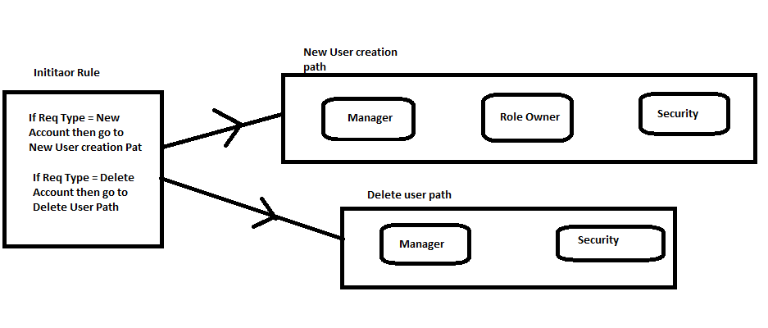
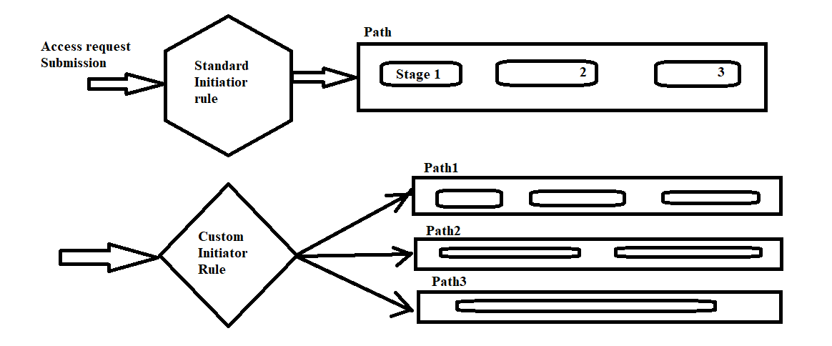
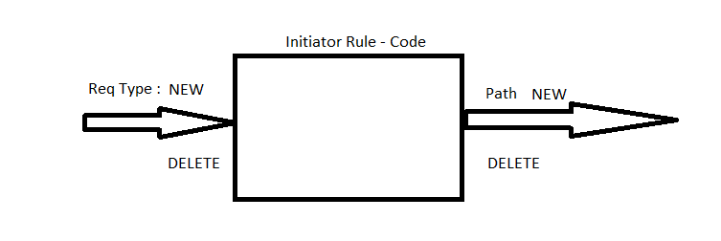

Agent Rule:
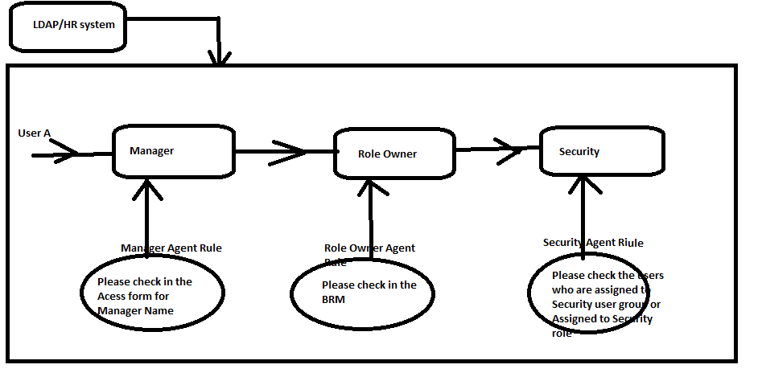

Routing Rule: (Detour/Alternate Path)
Conditions/Obstruction:
- User has a Risk
- Role Owner is missing
- Training Verification Failed
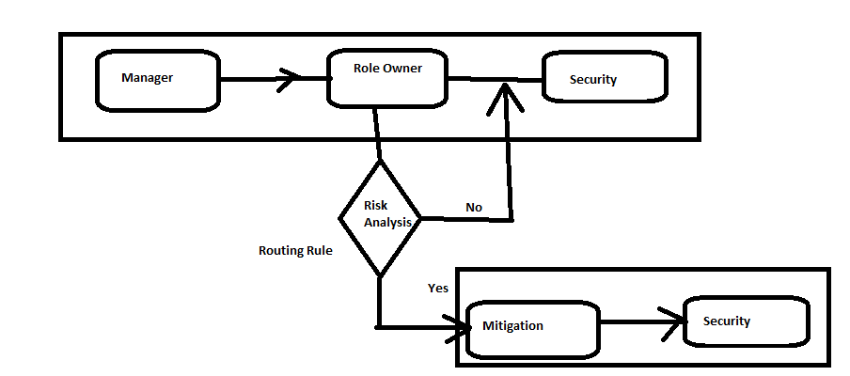

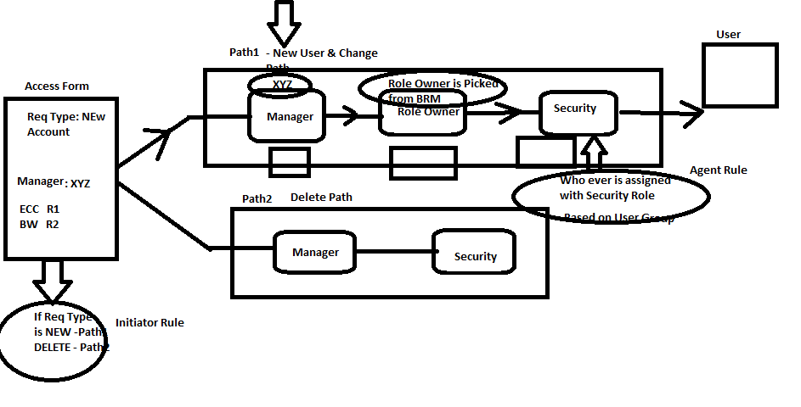

Rule Types:
It indicates how the rule is created or can be customized

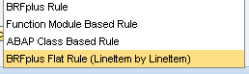

Custom rules can be created in the below T-codes:
BRF+ ---- > BRF Plus Rule & BRF Plus Flat Rule
SE38 ----- > ABAP Class Based
SE37 ------> Functional Module Based

- All SAP Standard Rules are Function Module Based Type
- When Standard rules are not satisfying your requirement then we need to customize the rules, this step is mandatory
- If you decide to use standard rules, this step can be skipped
- Define the Initiator rule & Notification Rule for the workflow in this step

- Maintain Agents
To customize Agent rules, when you don’t want to use the existing Agent rules in Step 2
Agent Types:
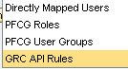
- Directly Mapped Users – Directly saying to system who is approver by mentioning his user id or name
- PFCG Roles – Whoever is assigned to a particular role
- PFCG User Groups – Who ever belongs to a particular user group
- GRC API rules – Whoever is defined in Step 2 of MSMP as Agent Rules

- API Rule :Security --- > Whoever is defined as Security lead under Access COntrol Owners
- User Group : ZSECURITY1 ----> Whoever is assigned with User Group SECURITY
- Role Based: ZSECURITY2 ---> Whoever is assigned with SECURITY Role
- Directly Mapped User: ZBASIS--- A1, A5, A7
Agent Purpose:
- Approval
- Notification
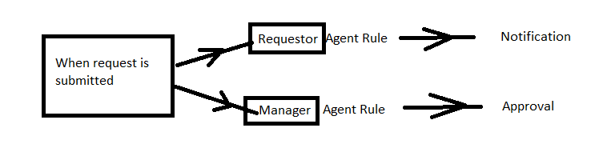

- Variables & Template
Customize templates… Mail formats…
Already we have predefined mail formats for every action/event.
SE61 – Customize notification templates

Workflow ------ > Initiator ------ > Rule Result ------ > Path ----- > Stages 1, 2, 3

Ex,, Access request Approved Template

Access request “number” submitted by “Requestor” is approved in “Stage Name” and now is pending in “Stage Name” Stage “XYZ”

- Maintain Paths
Only one path is available which is called GRAC_DEFAULT_PATH
This path has 3 stages.
- Manager
- Role Owner
- Security

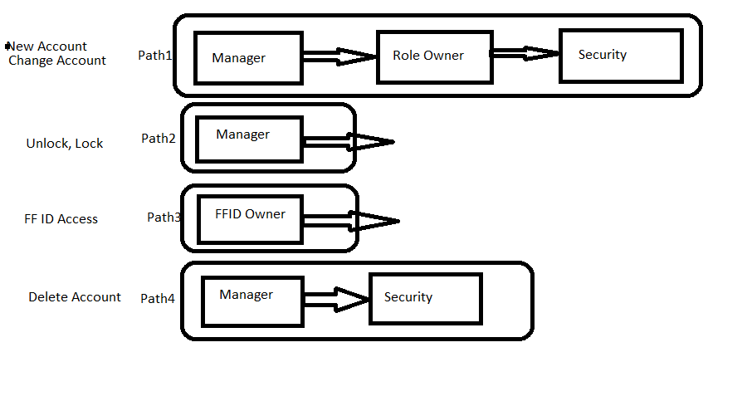
In Reality, we have many request types like
- New User Request
- Change user Request
- Delete User Request
- Lock Account
- Unlock Account
- FF ID Access
We need multiple paths as we have multiple request types

Modify Task Settings:
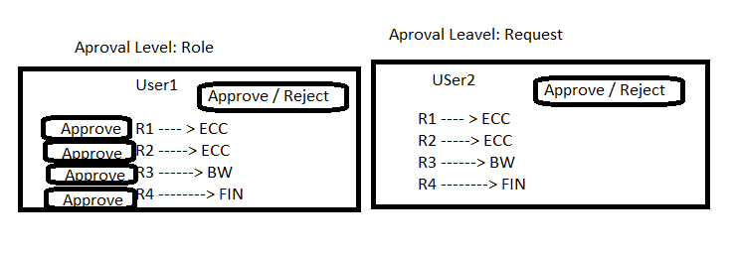
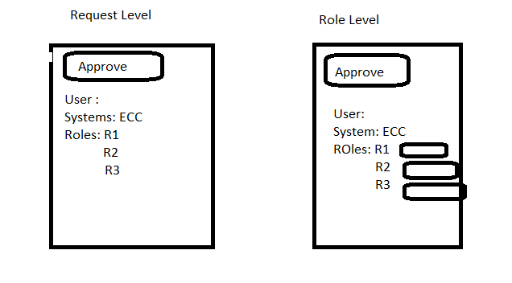
Maintain Route Mapping:
- Mapping Paths with Initiator rule
- Mapping Alternate path with Routing rule

No of Paths: 1
Initiator Rule: Standard

No of Paths: > 1
Initiator Rule: Custom
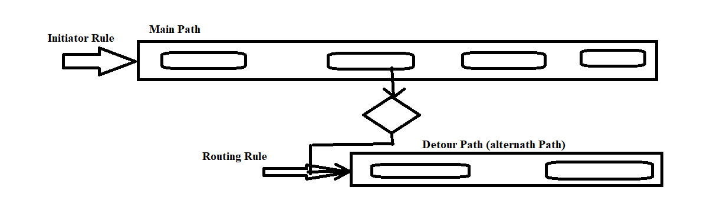

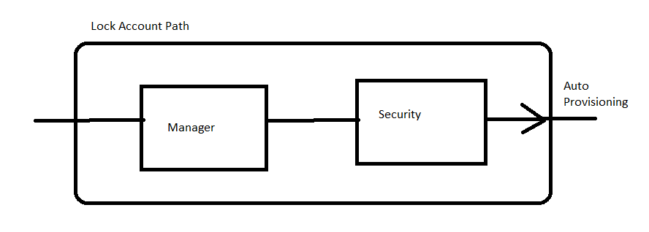

BRF+: Business Rules Framework
It can be accessed by below t-codes
- BRF+
- BRFPLUS
Or
SPRO --- > GRC ----> AC -----> Workflow for AC ------> Define BRF
Purpose: To customize Rules (Initiator/Agent/Routing/Notification)
- We are customizing the Initiator rule since standard default Initiator rule has only one rule result which can be linked to one path only.
- We need multiple rule results under the Initiator rule so that we can link them up with multiple paths.
- Hence we are going to BRF+ application to create Custom Initiator Rule with Multiple Rule Results

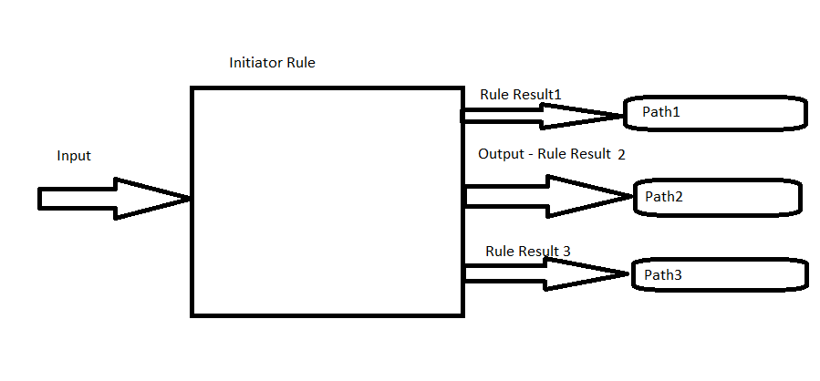

Default Initiator rule
Rule Result 1 | Path1

Custom Initiator Rule
Rule Result 1 | Path 1
Rule Result 2 | Path2
Rule Result 3 | Path3
Rule Result 4
Rule Result 5

How to create a custom Rule?
1) BRF+ Application ----- > BRF+ or BRFPLUS
2) ABAP Class based ---- > SE38
3) Functional Module Based ----- > SE37

Request Type | Custom Initiator Rule
New Account | Rule Result 1 | Path1 | NEW USER REQUEST
Change Account | Rule Result 2 | Path2 | CHANGE USER REQUEST
Delete Account | Rule Result 3 | Path3 | DELETE USER REQUEST
Lock Account | Rule Result 4 | Path4 | Lock REQUEST
Unlock Account | Rule Result 5 | Path5 | Unlock USER

Initiate the use of BRF+ from SPRO and create BRF+ Application:
Launch the BRF+ from SPRO:
GRC ---- > AC ------ > Workflow for Access Control ------ > Define Business Rule Framework
- Need to create Application under BRF+
- Application can be created from the below path in SPRO
GRC ---- > AC ------ > Workflow for Access Control ------ > Define Workflow-Related MSMP Rules
What is the difference between BRF+ rule and BRF+ Flat Rule?
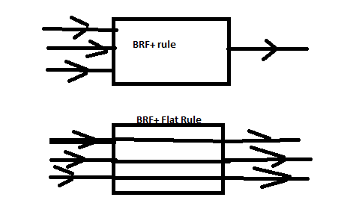
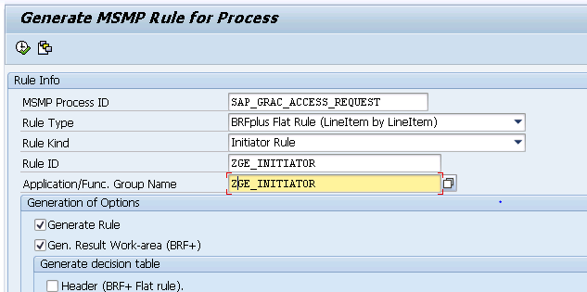

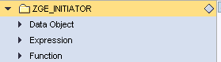

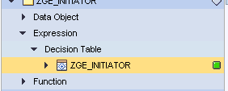
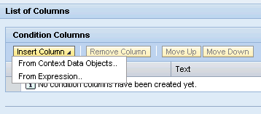

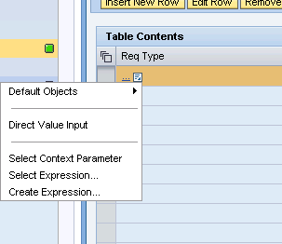
Direct Value Input

BRF+
A = B (decision Table)

MSMP
B = C

A = Request Type
B = Trigger Value
C = Path

Access request Workflow
ZPG_INITIATOR: REQ TYPE ------- > Rule Result ------- > Path ---- > Stages
001------- >PG_NEW------- >PG_NEW_USER_PATH
003 -------- >PG_DELETE ----- > PG_DELETE_USER_PATH
004------- >PG_LOCK------- >PG_MANAGER_PATH
005------- >PG_UNLOCK------- > PG_MANAGER_PATH
006------- >PG_FFID------- >PG_FFID_PATH

Why is it called as MSMP? (Multi Stage Multi Path)
Earlier in GRC 5.3, every request type has dedicated Initiator
GRC 5.X ---- > Multi Stage Single Path
GRC 10.X, 12.X ----- > Multi Stage Multi Path
In GRC 10, 10.1, 12, entire workflow (no of paths) has one initiator.
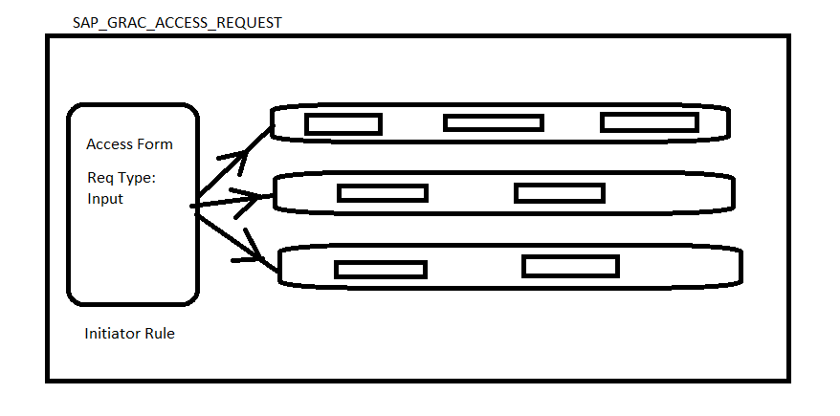

Testing:
Testing can be divided into 3 areas
- Request Submission
- Approval Stages
- Auto Provisioning
Users – Manager, Role Owner and Security, Risk Owner – have to exist in GRC system with relevant access to approve the requests in their respective stages
PG_MANAGER – Stage1
PG _ROLEOWNER – Stage 2
PG_SECURITY – Stage 3
Create PG_USER2
Delete PG_USER1
Ensure roles have approvers defined and check the settings for the role so that it should be visible for the user when filling the access form.
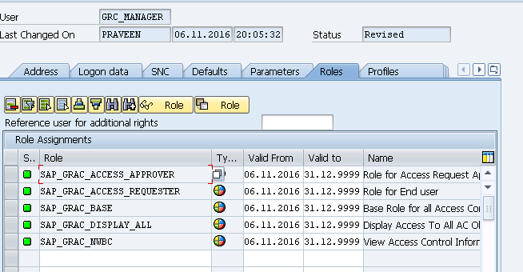

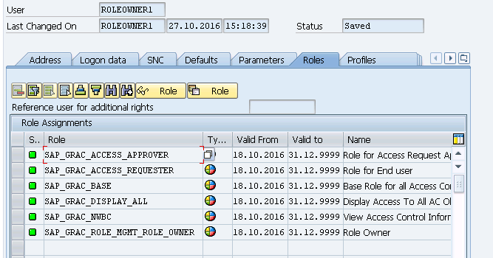

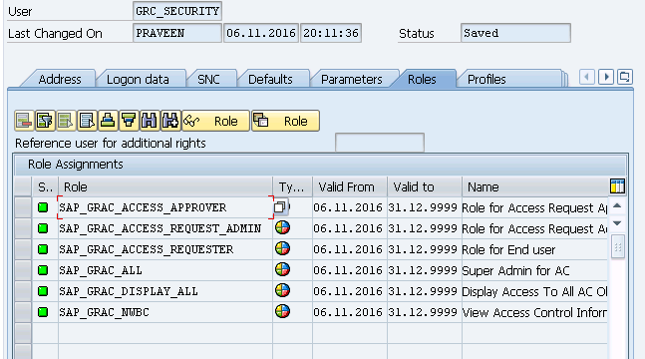

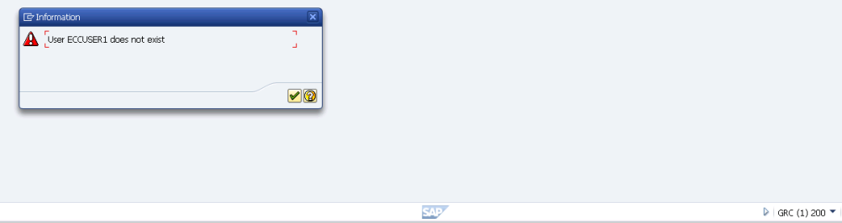

SLG1: Troubleshooting T-code
LPD_CUST: Customizing the NWBC Page – launch Pad

UAR: User Access Review is used by managers and role approvers to automate the periodic process of reviewing and reaffirming end user role assignments. The system notifies managers to review their direct reports' access to applications. ... Approvers either approve or remove the roles that are assigned to each user.

Segregation of Duties Review (SOD Review)
Segregation of Duties Review is a process where the system checks periodically for any risk and violations associated with a user or functions. This functionality can be used during the initial clean-up of risk violations as well as a long-term strategy to review and affirm previous Mitigation assignments.
When SOD review is performed, it generates requests automatically, based on organization’s internal policy. SOD review provides Workflow Based review and approval process.

Following paths in my MSMP Workflow
If User is Employee and New user – Path1 (2 Stage Approval)
If user is Employee and Change user – Path2
If user is Employee and Delete user – Path3
If user is Contractor and New user – Path4 (3 Stage Approval)
If user is Contractor and New user – Path5
If user is Contractor and New user – Path6

Upgrade:
10/ 10.1 ----- > 12.0
10 & 10.1 Support is officially stopped from Jan 2021

Scenario 1:
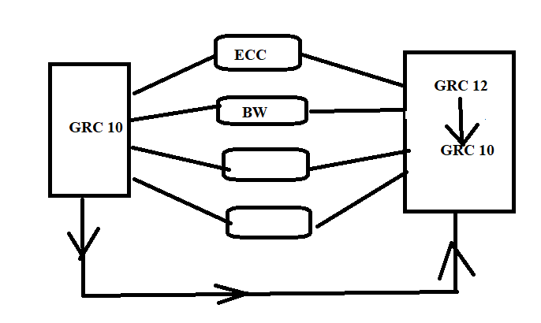
Scenario 2:

